**Optimizing Flight Booking Decisions through Machine Learning Price Predictions**

**TEAM ID:** **NM2023TMID25498**

**N.SHYLAJA (D4A262313E98AA18B664F1B278FC62B1)**

**K.R MADHUSHREE(22A20AD8085DFD78FA04C7330D95E963)**

**T.KESAVARAJA(259C44FBD31BA10BC354BDA00B25A2EE)**

**S.MALARVIZHLI(413A531C29338AC962A4C331F82CC28A)**

**INTRODUCTION:**

we will be **analyzing the flight fare prediction using Machine Learning dataset** using essential exploratory data analysis techniques then will **draw some predictions about the price of the flight based on some features** such as what type of airline it is, what is the arrival time, what is the departure time, what is the duration of the flight, source, destination and more.



In this article, we do prediction using machine learning which leads to below takeaways:

1. **EDA:** Learn the complete process of EDA
2. **Data analysis:** Learn to withdraw some insights from the dataset both mathematically and visualize it.
3. **Data visualization:** Visualising the data to get better insight from it.
4. **Feature engineering:** We will also see what kind of stuff we can do in the feature engineering part.

About the dataset

1. **Airline:** So this column will have all the types of airlines like Indigo, Jet Airways, Air India, and many more.
2. **Date_of_Journey:** This column will let us know about the date on which the passenger’s journey will start.
3. **Source:** This column holds the name of the place from where the passenger’s journey will start.
4. **Destination:** This column holds the name of the place to where passengers wanted to travel.
5. **Route:** Here we can know about that what is the route through which passengers have opted to travel from his/her source to their destination.
6. **Arrival_Time:** Arrival time is when the passenger will reach his/her destination.
7. **Duration:**Duration is the whole period that a flight will take to complete its journey from source to destination.
8. **Total_Stops:** This will let us know in how many places flights will stop there for the flight in the whole journey.
9. **Additional_Info:** In this column, we will get information about food, kind of food, and other amenities.
10. **Price:** Price of the flight for a complete journey including all the expenses before onboarding.

Importing Libraries

import numpy as np

import pandas as pd

import matplotlib.pyplot as plt

import seaborn as sns

from sklearn.preprocessing import StandardScaler

from sklearn.model_selection import train_test_split

from sklearn.metrics import mean_squared_error as mse

from sklearn.metrics import r2_score

from math import sqrt

from sklearn.linear_model import Ridge

from sklearn.linear_model import Lasso

from sklearn.tree import DecisionTreeRegressor

from sklearn.ensemble import RandomForestRegressor

from sklearn.preprocessing import LabelEncoder

from sklearn.model_selection import KFold

from sklearn.model_selection import train_test_split

from sklearn.model_selection import GridSearchCV

from sklearn.model_selection import RandomizedSearchCV

from prettytable import PrettyTable

Reading the training data of our dataset

Exploratory Data Analysis (EDA)

**Now here we will be looking at the kind of columns our dataset has.**

train_df.columns

**Output:**

Index(['Airline', 'Date_of_Journey', 'Source', 'Destination', 'Route',

'Dep_Time', 'Arrival_Time', 'Duration', 'Total_Stops',

'Additional_Info', 'Price'],

dtype='object')

**Here we can get more information about our dataset**

train_df.info()

**Output:**

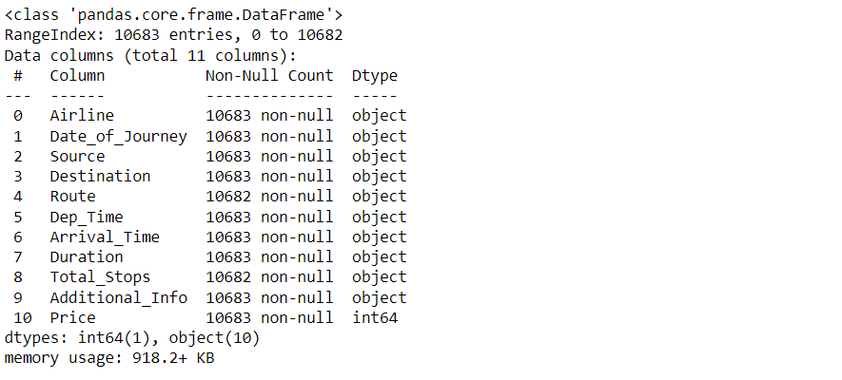

**To know more about the dataset**

train_df.describe()

**Output:**

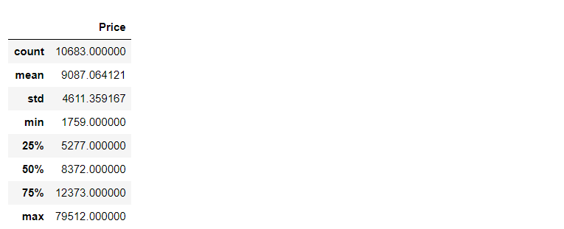

**Now while using the IsNull function we will gonna see the number of null values in our dataset**

train_df.isnull().head()

**Output:**

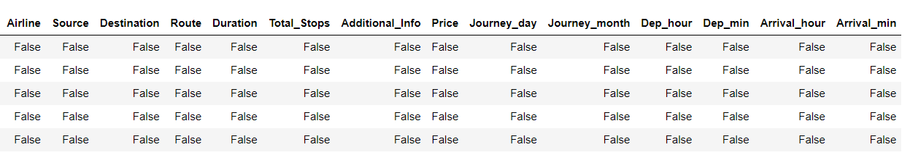

**Now while using the IsNull function and sum function we will gonna see the number of null values in our dataset**

train_df.isnull().sum()

**Output:**

Airline 0

Date_of_Journey 0

Source 0

Destination 0

Route 1

Dep_Time 0

Arrival_Time 0

Duration 0

Total_Stops 1

Additional_Info 0

Price 0

dtype: int64

**Dropping NAN values**

train_df.dropna(inplace = True)

**Duplicate values**

train_df[train_df.duplicated()].head()

**Output:**

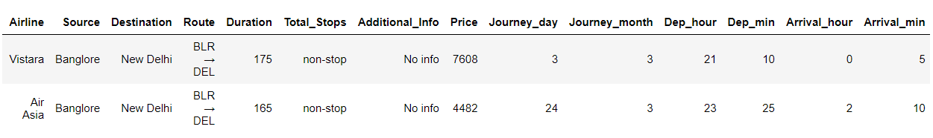

**Here we will be removing those repeated values from the dataset and keeping the in-place attribute to be true so that there will be no changes.**

train_df.drop_duplicates(keep='first',inplace=True)

train_df.head()

**Output:**

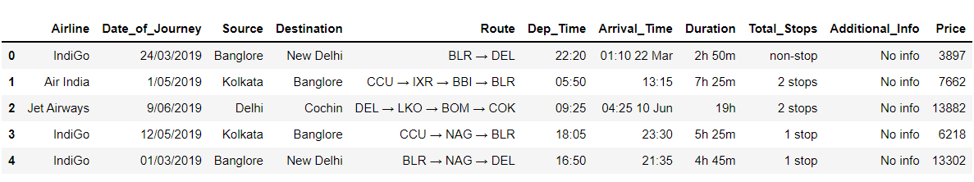

train_df.shape

**Output:**

(10462, 11)

**Checking the Additional_info column and having the count of unique types of values.**

train_df["Additional_Info"].value_counts()

**Output:**

No info 8182

In-flight meal not included 1926

No check-in baggage included 318

1 Long layover 19

Change airports 7

Business class 4

No Info 3

1 Short layover 1

2 Long layover 1

Red-eye flight 1

Name: Additional_Info, dtype: int64

**Checking the different Airlines**

train_df["Airline"].unique()

**Output:**

array(['IndiGo', 'Air India', 'Jet Airways', 'SpiceJet',

'Multiple carriers', 'GoAir', 'Vistara', 'Air Asia',

'Vistara Premium economy', 'Jet Airways Business',

'Multiple carriers Premium economy', 'Trujet'], dtype=object)

**Checking the different Airline Routes**

train_df["Route"].unique()

**Output:**See the code**.**

**Now let’s look at our testing dataset**

test_df = pd.read_excel("Test_set.xlsx")

test_df.head(10)

**Output:**

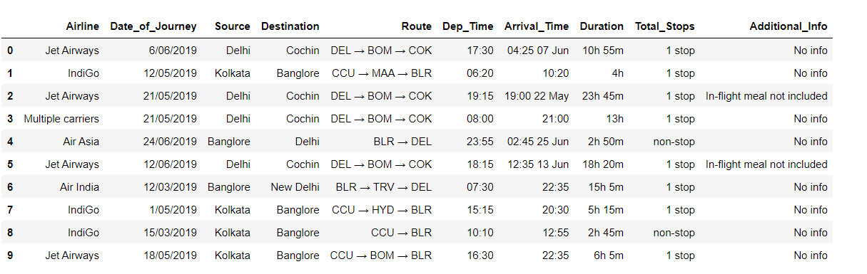

**Now here we will be looking at the kind of columns our testing data has.**

test_df.columns

**Output:**

Index(['Airline', 'Date_of_Journey', 'Source', 'Destination', 'Route',

'Dep_Time', 'Arrival_Time', 'Duration', 'Total_Stops',

'Additional_Info'],

dtype='object')

**Information about the dataset**

test_df.info()

**Output:**

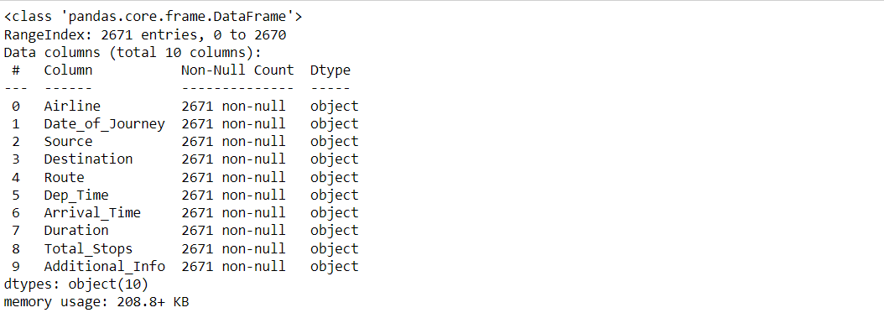

**To know more about the testing dataset**

test_df.describe()

**Output:**

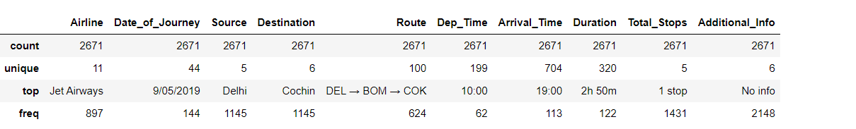

**Now while using the IsNull function and sum function we will gonna see the number of null values in our testing data**

test_df.isnull().sum()

**Output:**

Airline 0

Date_of_Journey 0

Source 0

Destination 0

Route 0

Dep_Time 0

Arrival_Time 0

Duration 0

Total_Stops 0

Additional_Info 0

dtype: int64

Data Visualization

**Plotting Price vs Airline plot**

sns.catplot(y = "Price", x = "Airline", data = train_df.sort_values("Price", ascending = False), kind="boxen", height = 8, aspect = 3)

plt.show()

**Output:**

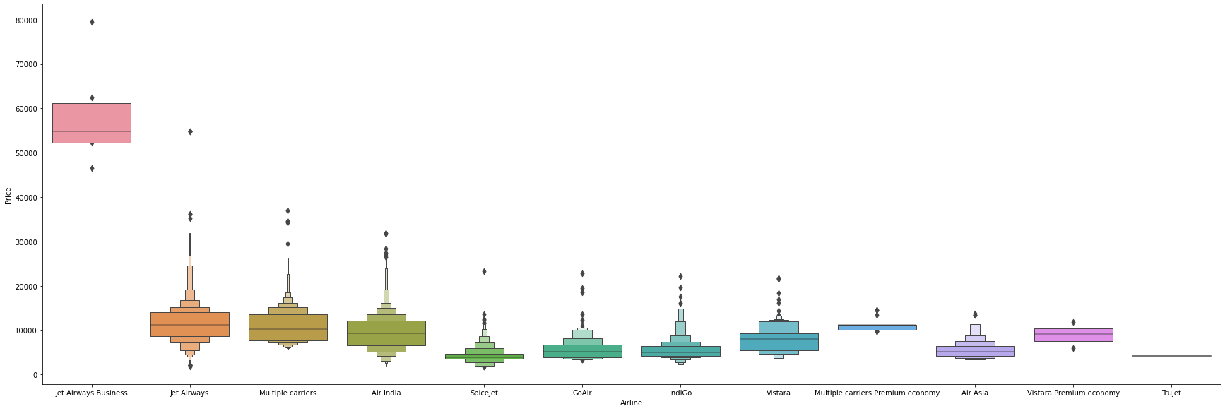

**Inference:** Here with the help of the cat plot we are trying to plot the boxplot between the price of the flight and airline and we can conclude that **Jet Airways has the most outliers in terms of price**.

**Plotting Violin plot for Price vs Source**

sns.catplot(y = "Price", x = "Source", data = train_df.sort_values("Price", ascending = False), kind="violin", height = 4, aspect = 3)

plt.show()

**Output:**

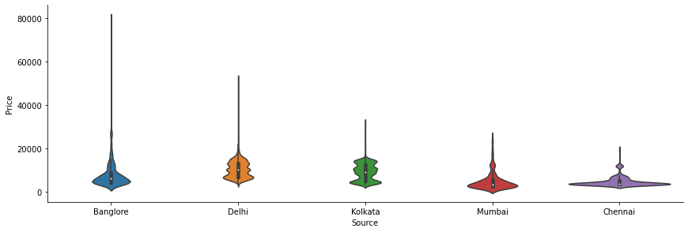

**Inference:** Now with the help of cat plot only we are plotting a box plot between the price of the flight and the source place i.e. **the place from where passengers will travel to the destination and we can see that Banglore as the source location has the most outliers while Chennai has the least.**

**Plotting Box plot for Price vs Destination**

sns.catplot(y = "Price", x = "Destination", data = train_df.sort_values("Price", ascending = False), kind="box", height = 4, aspect = 3)

plt.show()

**Output:**

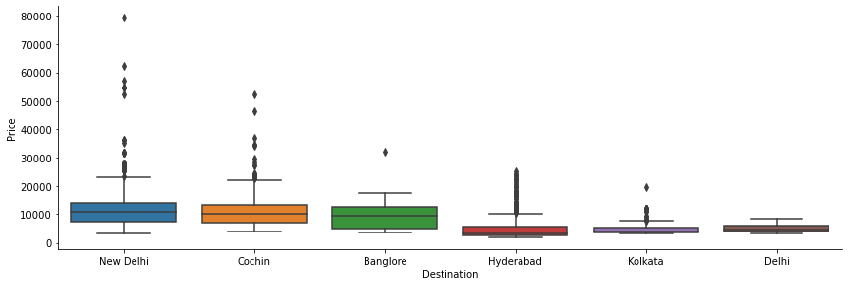

**Inference:** Here we are plotting the box plot with the help of a cat plot between the price of the flight and the destination to which the passenger is travelling and figured out that **New Delhi has the most outliers and Kolkata has the least.**

Feature Engineering

**Let’s see our processed data first**

train_df.head()

**Output:**

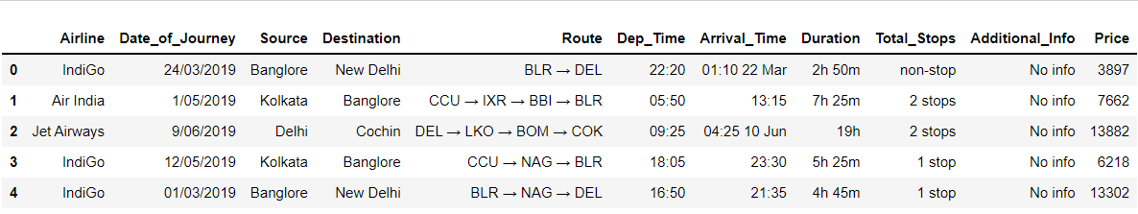

**Here first we are dividing the features and labels and then converting the hours in minutes.**

train_df['Duration'] = train_df['Duration'].str.replace("h", '*60').str.replace(' ','+').str.replace('m','*1').apply(eval)

test_df['Duration'] = test_df['Duration'].str.replace("h", '*60').str.replace(' ','+').str.replace('m','*1').apply(eval)

**Date_of_Journey:** Here we are organizing the format of the date of journey in our dataset for better preprocessing in the model stage.

train_df["Journey_day"] = train_df['Date_of_Journey'].str.split('/').str[0].astype(int)

train_df["Journey_month"] = train_df['Date_of_Journey'].str.split('/').str[1].astype(int)

train_df.drop(["Date_of_Journey"], axis = 1, inplace = True)

**Dep_Time:** Here we are converting departure time into hours and minutes

train_df["Dep_hour"] = pd.to_datetime(train_df["Dep_Time"]).dt.hour

train_df["Dep_min"] = pd.to_datetime(train_df["Dep_Time"]).dt.minute

train_df.drop(["Dep_Time"], axis = 1, inplace = True)

**Arrival_Time:**Similarly we are converting the arrival time into hours and minutes.

**Now after final preprocessing let’s see our dataset**

train_df.head()

**Output:**

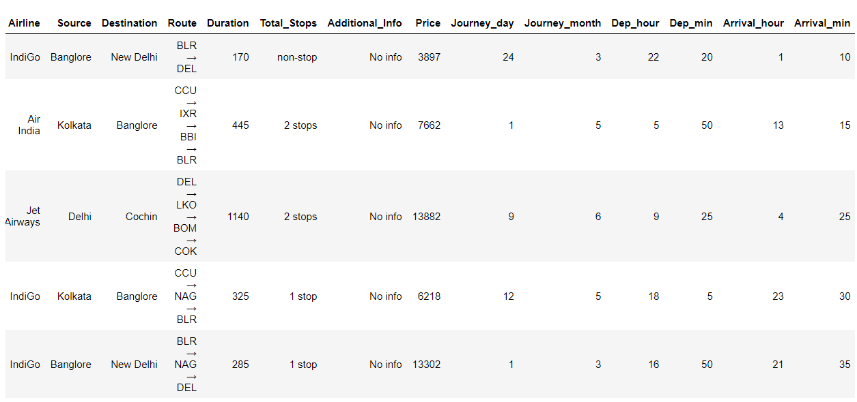

**Plotting Bar chart for Months (Duration) vs Number of Flights**

plt.figure(figsize = (10, 5))

plt.title('Count of flights month wise')

ax=sns.countplot(x = 'Journey_month', data = train_df)

plt.xlabel('Month')

plt.ylabel('Count of flights')

for p in ax.patches:

ax.annotate(int(p.get_height()), (p.get_x()+0.25, p.get_height()+1), va='bottom', color= 'black')

**Output:**

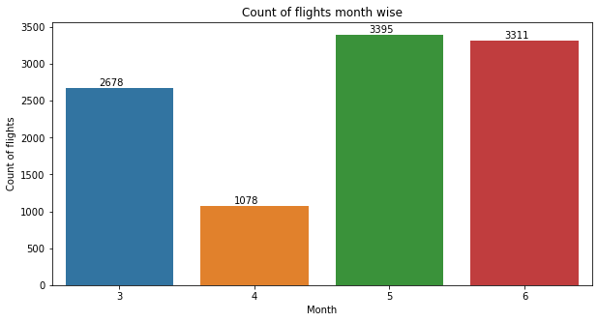

**Inference:** Here in the above graph we have plotted the count plot for journey in a month vs several flights and got to see that **May has the most number of flights.**

**Plotting Bar chart for Types of Airline vs Number of Flights**

plt.figure(figsize = (20,5))

plt.title('Count of flights with different Airlines')

ax=sns.countplot(x = 'Airline', data =train_df)

plt.xlabel('Airline')

plt.ylabel('Count of flights')

plt.xticks(rotation = 45)

for p in ax.patches:

ax.annotate(int(p.get_height()), (p.get_x()+0.25, p.get_height()+1), va='bottom', color= 'black')

**Output:**

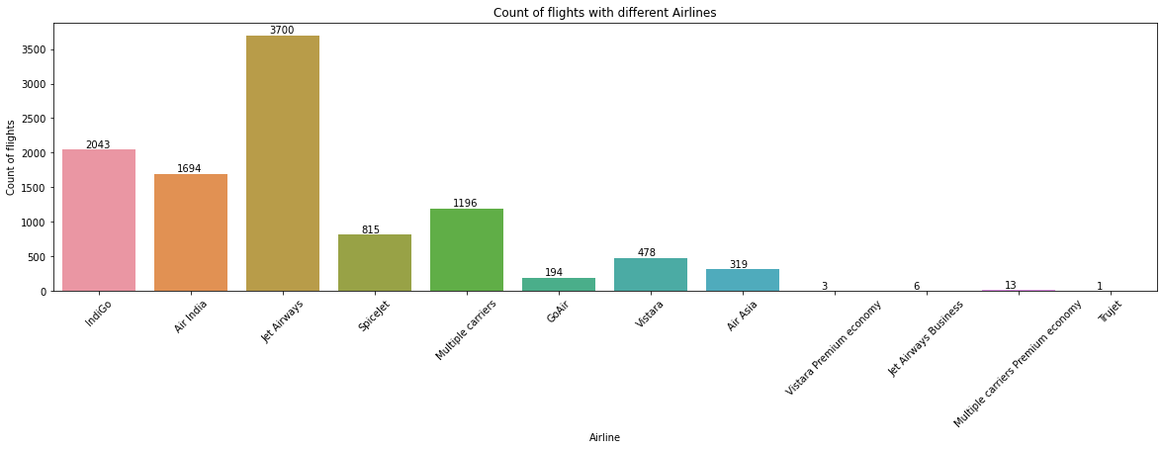

**Inference:** Now from the above graph we can see that between the type of airline and**count of flights we can see that Jet Airways has the most flight boarded.**

**Plotting Ticket Prices VS Airlines**

plt.figure(figsize = (15,4))

plt.title('Price VS Airlines')

plt.scatter(train_df['Airline'], train_df['Price'])

plt.xticks

plt.xlabel('Airline')

plt.ylabel('Price of ticket')

plt.xticks(rotation = 90)

**Output:**

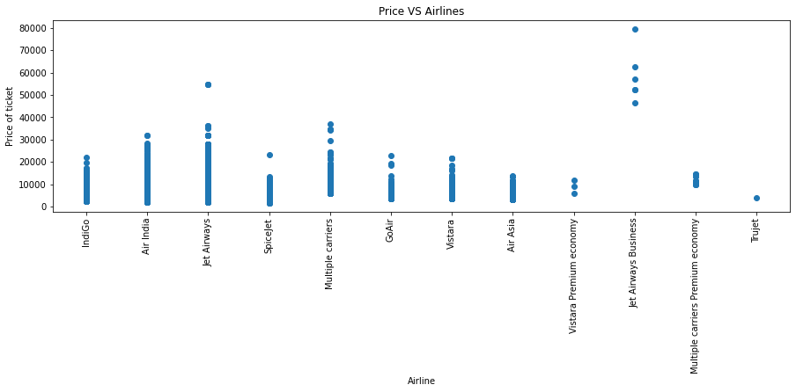

Correlation between all Features

**Plotting Correlation**

plt.figure(figsize = (15,15))

sns.heatmap(train_df.corr(), annot = True, cmap = "RdYlGn")

plt.show()

**Output:**

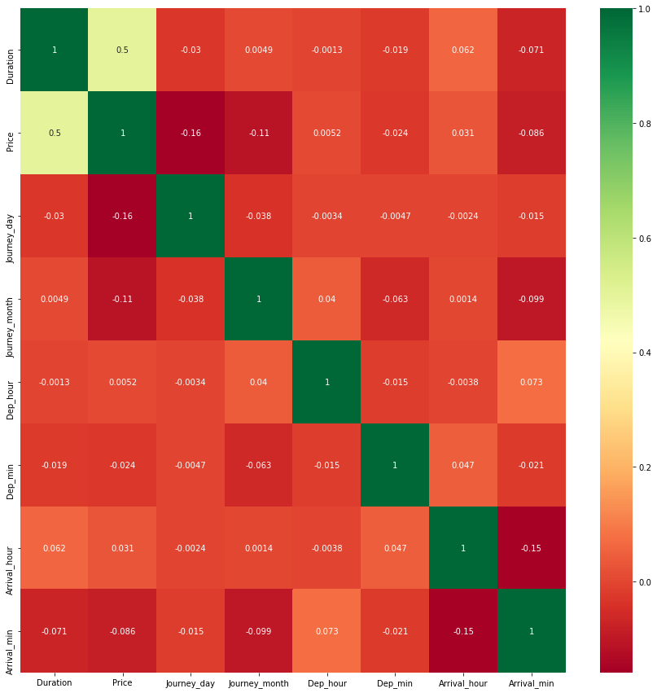

**Dropping the Price column as it is of no use**

data = train_df.drop(["Price"], axis=1)

**Dealing with Categorical Data and Numerical Data**

train_categorical_data = data.select_dtypes(exclude=['int64', 'float','int32'])

train_numerical_data = data.select_dtypes(include=['int64', 'float','int32'])

Optimizing Flight Booking Decisions through Machine Learning Price Predictions

test_categorical_data = test_df.select_dtypes(exclude=['int64', 'float','int32','int32'])

test_numerical_data = test_df.select_dtypes(include=['int64', 'float','int32'])

train_categorical_data.head()

**Output:**

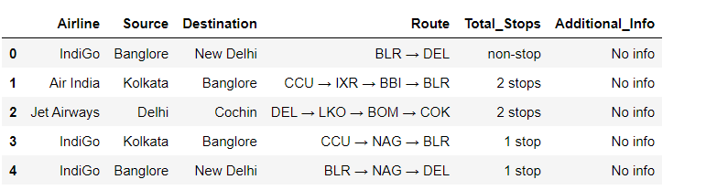

**Output:**

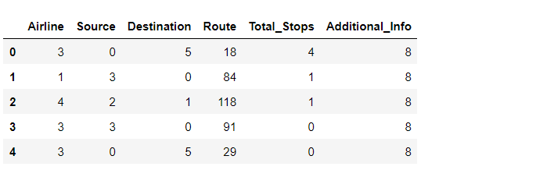

**Concatenating both Categorical Data and Numerical Data**

X = pd.concat([train_categorical_data, train_numerical_data], axis=1)

y = train_df['Price']

test_set = pd.concat([test_categorical_data, test_numerical_data], axis=1)

X.head()

**Output:**

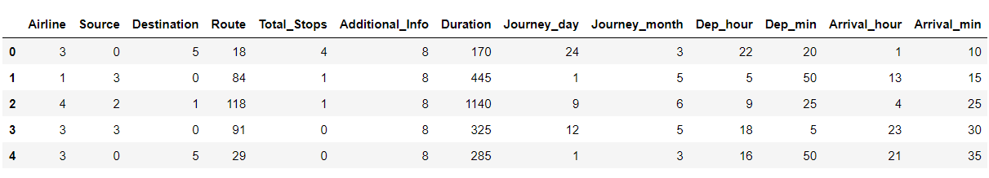

y.head()

**Output:**

0 3897

1 7662

2 13882

3 6218

4 13302

Name: Price, dtype: int64

Conclusion

So as we saw that we have done a complete EDA process, getting data insights, feature engineering, and data visualization as well so after all these steps one can go for the prediction using machine learning model-making steps.